34.75: a) Reflection from the front face of the glass means that the image is just h
below the glass surface, like a normal mirror.
b) The reflection from the mirrored surface behind the glass will not be affected because of the intervening glass. The light travels through a distance 2d of glass, so the path through the glass appears to be 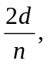 and the image appears to be 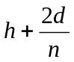 behind the front surface of the glass.
c) The distance between the two images is just 